Chest X-ray
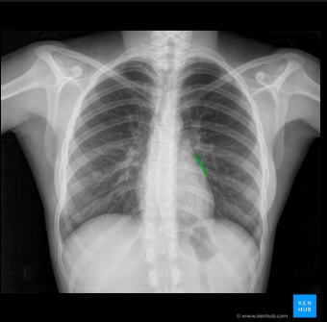
PATIENT INFORMATION:
- Age: Not specified
- Gender: Not specified

CLINICAL INDICATION:
Routine examination

TECHNIQUE:
Frontal and lateral radiographs of the chest

FINDINGS:
The cardiomediastinal contours, lungs, pleura, osseous structures and visualized upper abdomen are normal.

IMPRESSION:
Unremarkable radiographs of the chest.

